Application Form
－Ideas for ”Try Zero G ” by JAXA Astronaut Yui－

# Please print all information about everyone when you are applying as a team. If you are applying as an agency, please include the names of your agency and a representative, as well as the number of people.

Deadline: Jan.22, 2015

Name: Miss Rewadee Pensri

Address: 52 M.5 Samruan District : Srisamrong Province : Sukhothai

Country: Thailand

Phone: 089-9593445 Thailand

Age: 37 year’s old Gender: Female Occupation: Teacher

E-mail: krurayka@gmail.com

Name (Miss Rewadee Pensri), Address (52 M.5 Samruan District : Srisamrong Province : Sukhothai Thailand), Phone(089-9593445)
Activities for Astronaut Yui to conduct in Kibo.
(Please add pictures/images, if needed.)

1. Fold the Origami’s paper to the turbine . As show below.

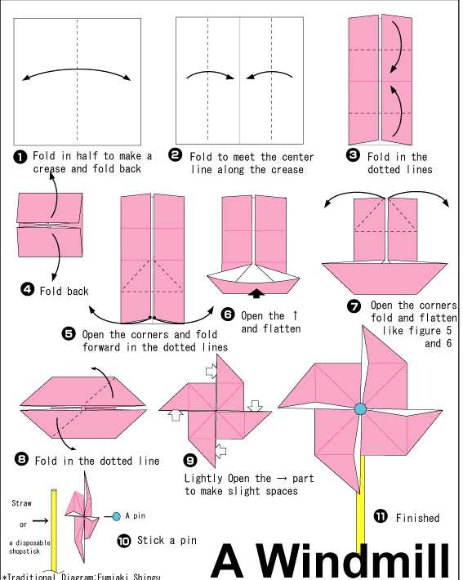

2.Use the one straw and blow the air to pass the straw by mount. The air from straw will pass the turbine.
3. Observe the rotation of the turbine.

Outcome of the activity and the reasons.
(Please add pictures/images, if needed.)

The results from experiments on earth :

The rotation of the turbine is more than one round when the turbine is collided with the air from mount

The Expected results in weightlessness :

The turbine is not complete for rotation. The turbine will revolve not complete for one cycle . When we blow the air from mount to pass the turbine.

Name (Miss Rewadee Pensri), Address (52 M.5 Samruan District : Srisamrong Province : Sukhothai Thailand), Phone(089-9593445)
Activities for Astronaut Yui to conduct in Kibo.
(Please add pictures/images, if needed.)

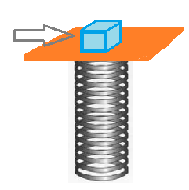

1. Background sheet folded into a square( 12.5 x 12.5cm)
2. Placed the background sheet on the spring is positioned vertically .
3. Try putting wood sticks on background sheet above.
4. Use your finger to eject background sheet sharply
observed wood sticks.
5. Change material is Aluminum, iron and plastic and
repeated experiments

Outcome of the activity and the reasons.
(Please add pictures/images, if needed.)

The results from experiments on earth :

When use your finger to eject background sheet sharply observed wood sticks. The wood sticks to fall in the slinky according to the first Newton’s law. And then It is the same for all objects.

The Expected results in weightlessness :

When use your finger to eject background sheet sharply observed wood sticks. The wood sticks not fall in the slinky but the wood sticks float away the background sheet

